ARE YOU MISSING ANYTHING?
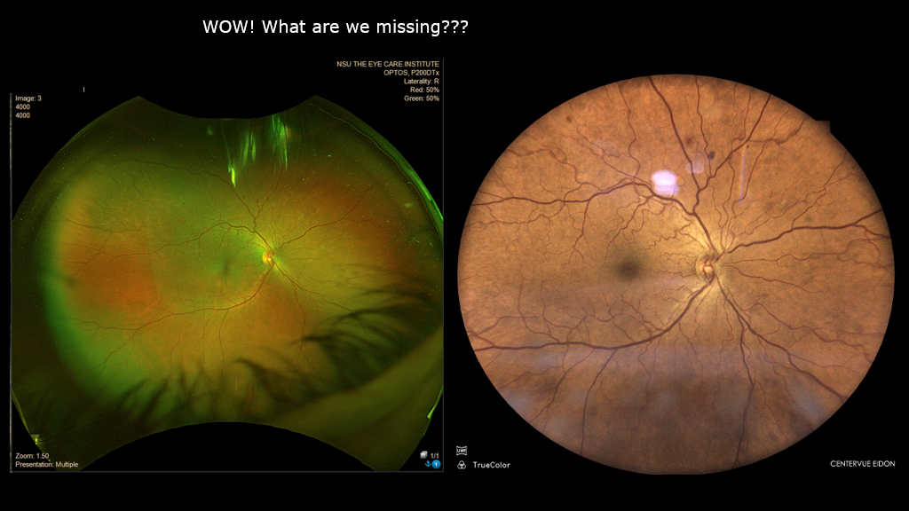
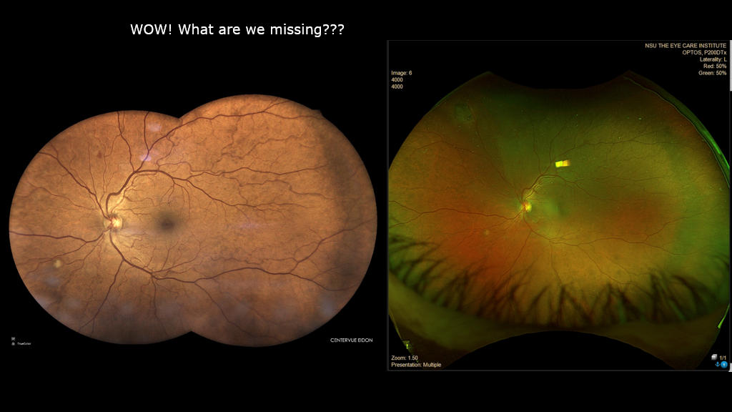

 Eidon UWF Images Courtesy of Julie Rodman OD, FAAO
Optos vs Eidon Side by Side

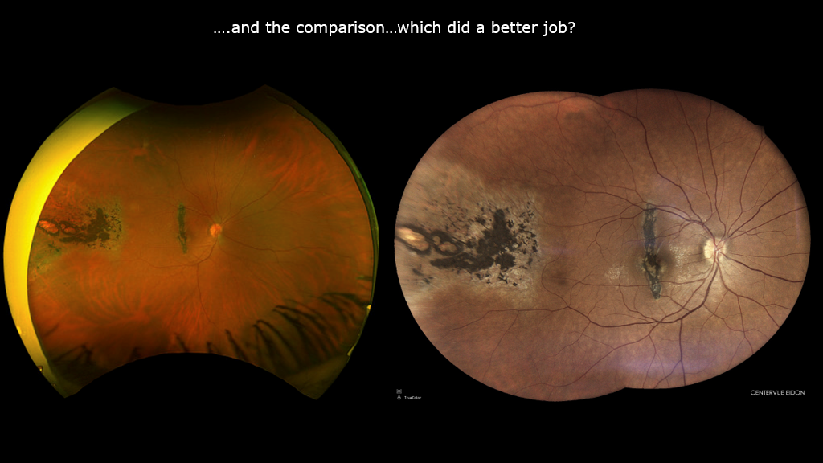

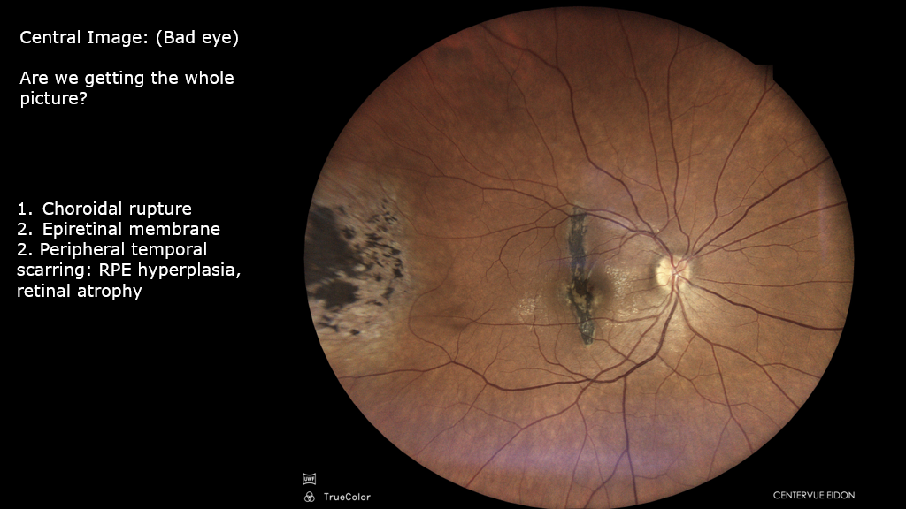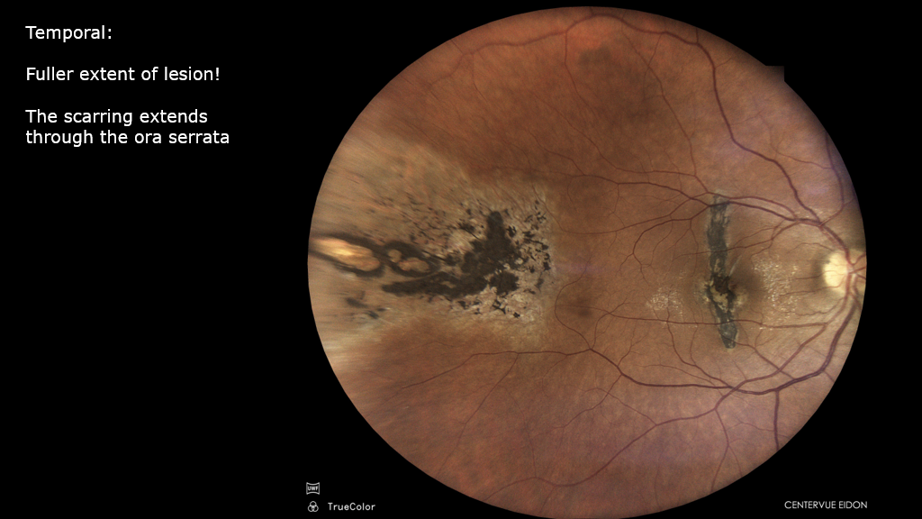

Eidon UWF Images Courtesy of Julie Rodman OD, FAAO

